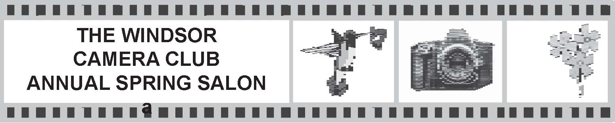

The Annual Salon and Banquet is held in the spring of the year in recognition of photographic excellence.

Entry Deadline for the Salon will normally be the Last Club Meeting in April
Changes for the 2021 Salon only.
For the competition year 2020 - 2021 Salon, there are no Print categories and a Monochrome Digital Image category has been added. Also 6 entries per category will be allowed instead of the usual four.
For a list of the awards, see the section in the handbook titled:
Salon and Annual Rosettes, Medallions and Trophies

Six images can be entered in each of the following categories:
- Open Digital Image
- Nature Digital Image
- Altered Reality Digital Image
- Monochrome Digital Image
- Portrait - See definition below
Notes:
- Only digital images that have qualified in monthly competition during the 12 months starting in April 2020 of the previous calendar year to March 2021 of the current calendar year may be entered.
- Salon entries in Open, Nature and Altered Reality Categories must follow the same definitions used for the monthly Competitions.
- Monochrome Digital Images must be entered in the Monochrome Digital Image Category.
- Salon entries in the Digital Image Portrait Category, must be of one person from close up to full length. The portrait can be in an environment, as long as the person is the main subject.
- Images that were entered in the Assignment Category in the monthly competitions can be entered in the appropriate Salon Categories.
- An image cannot be entered into more than one category.
- The name of an image that was previously accepted can be corrected for entry in the Salon, with the approval of Salon Committee.

Submission of Entries:

- By April 20, 2021 the entry form must be emailed to Charles Wilson at chsawilson@gmail.com
- We already have all the digital files, so there is no need to re-enter them.
- Any questions or for more information, email Charles Wilson at chsawilson@gmail.com
The Windsor Camera Club Salon Entry Form 2021

Name ______________________________________________

- Open Digital Image
  - __________________________
  - __________________________
  - __________________________
  - __________________________
  - __________________________
  - __________________________

- Nature Digital Image
  - __________________________
  - __________________________
  - __________________________
  - __________________________
  - __________________________
  - __________________________

- Altered Reality Digital Image
  - __________________________
  - __________________________
  - __________________________
  - __________________________
  - __________________________
  - __________________________

- Monochrome Digital Image
  - __________________________
  - __________________________
  - __________________________
  - __________________________
  - __________________________
  - __________________________

- Digital Image Portrait
  - __________________________
  - __________________________
  - __________________________
  - __________________________
  - __________________________
  - __________________________

