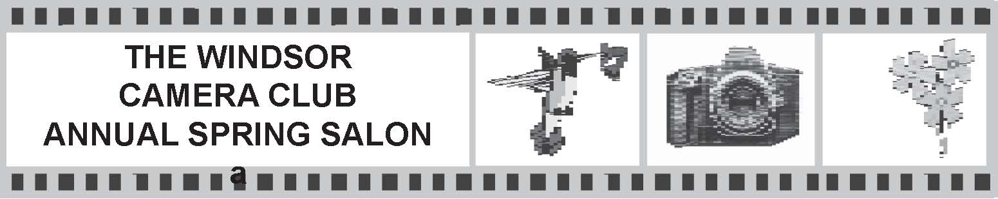

The Annual Salon and Banquet is held in the spring of the year in recognition of photographic excellence.

Entry Deadline for the Salon will be the Last Club Meeting in April

For a list of the awards, see the section in the handbook titled:
Salon and Annual Rosettes, Medallions and Trophies

Four images can be entered in each of the following categories:
- Open Digital Image
- Nature Digital Image
- Altered Reality Digital Image
- Monochrome Print
- Open Colour Print
- Nature Colour Print
- Portrait - See definition below
Notes:
- Only digital images and prints that have qualified in monthly competition during the 12 months starting in April of the previous calendar year to March of the current calendar year may be entered.
- Salon Entries cannot change media except that if a print that has qualified in monthly competition during the competition year fits the Altered Reality Category, its associated digital file may be entered in the Altered Reality Digital Category. Such a Print can still be entered in the Open Colour Print Category.
- Salon entries in Open, Nature and Altered Reality Categories must follow the same definitions used for the monthly Competitions.
- Monochrome Prints must be entered in the Monochrome Print Category.
- Salon entries in the Portrait Category, either Digital or Print, must be of one person from close up to full length. The portrait can be in an environment, as long as the person is the main subject.
- Images that were entered in the Assignment Category in the monthly competitions can be entered in the appropriate Salon Categories.
- An image cannot be entered into more than one category.
- If a print that qualified during the competition year was lost or damaged and the maker wants to enter the image in the salon, a duplicate image can be submitted for approval by the Salon Committee.
- The name of an image that was previously accepted can be corrected for entry in the Salon, with the approval of Salon Committee.

Submission of Entries:

- By April 16, 2019 the entry form must be handed in at the Competition night meeting or emailed to Bob Major at bmajor55@gmail.com
- Prints must be handed in by the April 16, 2019 meeting.
- We already have all the digital files, so there is no need to re-enter them.
- Any questions or for more information, email Bob Major at bmajor55@gmail.com
The Windsor Camera Club Salon Entry Form 2019

Name ______________________________________________

- Open Digital Image
  - __________________________
  - __________________________
  - __________________________
  - __________________________

- Nature Digital Image
  - __________________________
  - __________________________
  - __________________________
  - __________________________

- Altered Reality Digital Image
  - __________________________
  - __________________________
  - __________________________
  - __________________________

- Monochrome Print
  - __________________________
  - __________________________
  - __________________________
  - __________________________

- Open Colour Print
  - __________________________
  - __________________________
  - __________________________
  - __________________________

- Nature Colour Print
  - __________________________
  - __________________________
  - __________________________
  - __________________________

- Portrait
  - __________________________
  - __________________________
  - __________________________
  - __________________________

